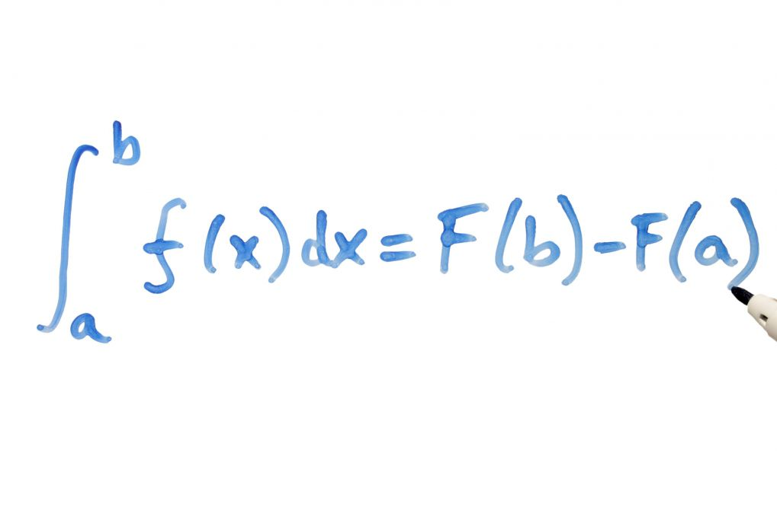
FOLDABLE RUBRIC
ACCURACY 20% | - ALL CONCEPTS MUST BE PRESENTED WITHIN THE FOLDABLE  - ITEMS MAY BE LISTED ON THE BACK AND FRONT OF NOTECARDS. (IF ITEMS ARE LOCATED ON THE BACK OF CARDS THEY MUST BE VISIBLE BY FLIPPING CARDS.)  - ITEMS MAY BE LISTED ON THE FOLDABLE ITSELF
CREATIVITY 80% | - NOTES MUST BE PRINTED NEATLEY OR TYPED ON CARDS OR WITHIN THE FOLDABLE. LAMINATED CARDS ARE ALSO ACCEPTABLE.  - THE COVER MUST PRESENT A CREATIVE THEME THAT IS USED THROUGHOUT THE PROJECT (SPORTS, MATH, SCHOOL MASCOT, ECT.)  - ADDITIOAL ITEMS MUST BE ADDED TO THE FRONT/BACK/INSIDE OF THE FOLDABLE TO ENHANCE THE THEME. (CUT-OUTS, STICKERS, DYE-CUTS, STRING, FABRIC ECT.)  - YOU MUST INCLUDE ITEMS OUTSIDE OF JUST MARKERS, CRAYONS, COLORED PENCILS, TO PROMOTE YOUR CREATIVITY ON THE OUTSIDE.  - NAME MUST BE VISIBLE ON BACK COVER OF THE FOLDABLE

FOLDABLES WILL BE GRADED BY A TEAM OF TEACHERS (3) AND THE AVERAGE GRADE WILL BE ASSIGNED. THE MORE YOUR PROJECT STANDS OUT FROM OTHERS THE BETTER THE CREATIVITY GRADE WILL BE.
FOLDABLES ARE DUE ON FRIDAY 4/27/18 BY 2:00PM.

NO LATE FOLDABLES WILL BE ACCEPTED. NO EXCEPTIONS. IF YOU FEEL THERE WILL BE AN ISSUE THEN I WOULD ADVISE YOU TURN YOUR FOLDABLE IN EARLY.

